**DATATYPES IN JAVA**

**1. What are the data types present in java and its size?**

Ans: -

|  |  |  |
| --- | --- | --- |
| **Data Type** | **Size** |  |
| Byte | 1 byte |  |
| Short | 2 bytes |  |
| Int | 4 bytes |  |
| long | 8 bytes |  |
| float | 4 bytes |  |
| double | 8 bytes |  |
| boolean | 1 bit |  |
| char | 2 bytes |  |
|  |  |  |

**2. What is Wrapper class?**

Ans: - A Wrapper class is a class whose object wraps or contains a primitive data types. When we create an object to a wrapper class, it contains a field and in this field, we can store a primitive data types.

**3. Uses of datatypes and wrapper class in java?**

Ans: - Use of Data type:

1. Allocates sequence set of bytes.
2. It indicates the type of data can be stored in the variable.

Use of wrapper class:

1. They convert primitive data types into objects.
2. Data structure in the Collection framework, such as Arraylist and Vector, store only objects (reference type) and not primitive type.

**4. The char data type size in java is 2 bytes, what are its benefits?**

Ans: -

**5. Which Language does not support any data type and what is the problem if not supports?**

Ans: - The language like HTML, PHP, Python doesn’t support the concept of data types.

**->** It create a problem that we can’t create new data structure.

**6. What is the difference between Wrapper class and data type in java?**

Ans: - The primitive wrapper classes create instantiated objects and methods that inherit but hide the primitive data types, not like variables that are assigned the data type values.

**7. How to get range of each datatype?**

Ans: - Java provides two pre-defined constants to get the range of primitive data types.

i. MAX_VALUE

ii. MIN_VALUE

**8. Which class is responsible for data type manipulation?**

Ans: - Wrapper class responsible for data type manipulation.

**9. Which method is used to convert String to Specific data type?**

Ans: - We can convert String to an int in java using Integer.parseInt() method. To convert String into Integer, we can use Integer.valueOf() method which returns instance of Integer class.

**10. Which method is used to convert a datatype to String format?**

Ans: - To convert one object to String in Java is just calling the toString() method, but since here we need to convert primitive int to String, it is better to use String.valueOf(int) method.

**11. Is wrapper class inherit or not, give reason?**

Ans: - Wrapper class cannot be inherited because these are defined as final, according to specification of java, final class cannot inherited.

**12. What is unboxing and how to implement in java?**

Ans: - Converting an object of a wrapper type to its corresponding primitive value is called unboxing.

E.g.: Integer no1 = 11;

int no2 = Integer.valueOf (no1);

**13. What is boxing and how to use in program?**

Ans: - Converting primitive value to wrapper class object is called boxing.

Example: int x = 10;

Integer y = new Integer (x);

**14. What is auto-boxing?**

Ans: - A primitive data type is converted into an object automatically is known as Auto Boxing. This is implemented in latest JDK.

**15. Which coding types is used for data type characters in Java?**

Ans: - Java support UNICODE standard for character datatype.

**16. What is primitive and non-primitive datatypes?**

Ans: - Primitive data type is predefined datatype which are supported by the programming language.

i.e.: int, char, float, double

A non-primitive data types are created by programmer and is not defined

by java (Except for Sring).

i.e.: String, Array, Class.

**17. Tree Structure of primitive and non-primitive datatypes.**

Ans: -

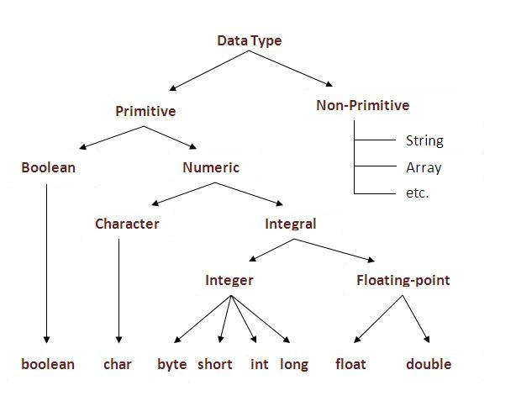

**18. Different types of constant in java?**

Ans: -

Character constant ---- ‘A’

String constant ---- “A”

Float constant ---- 3.2f

Double constant ---- 3.2

Boolean constant ---- true/false

Integer constant ---- 5

Long constant ---- 5L

Octal constant ---- 05

Hexa-Decimal constant ---- 0x5

Binary constant ---- 0b10

**19. Is String a datatype in java?**

Ans: - String is not a primitive datatype.

**20. Program to add between two number using BigInteger?**

Ans: -

import java.math.*;

class Test

{

public static void main(String[] args)

{

BigInteger no1 = new BigInteger("100");

BigInteger no2 = new BigInteger("200");

BigInteger no3 = no1.add(no2);

System.out.println("After add : "+no3);

}

}